**Project Design Phase-II**

**Data Flow Diagram & User Stories**

|  |  |
| --- | --- |
| Date | 28 June 2025 |
| Team ID | LTVIP2025TMID59738 |
| Project Name | Flightfinder: Navigating Your Air Travel Options |
| Maximum Marks | 4 Marks |

**Data Flow Diagrams:**

A Data Flow Diagram (DFD) is a traditional visual representation of the information flows within a system. A neat and clear DFD can depict the right amount of the system requirement graphically. It shows how data enters and leaves the system, what changes the information, and where data is stored.



**Example:** [**(Simplified)**](https://developer.ibm.com/patterns/visualize-unstructured-text/)

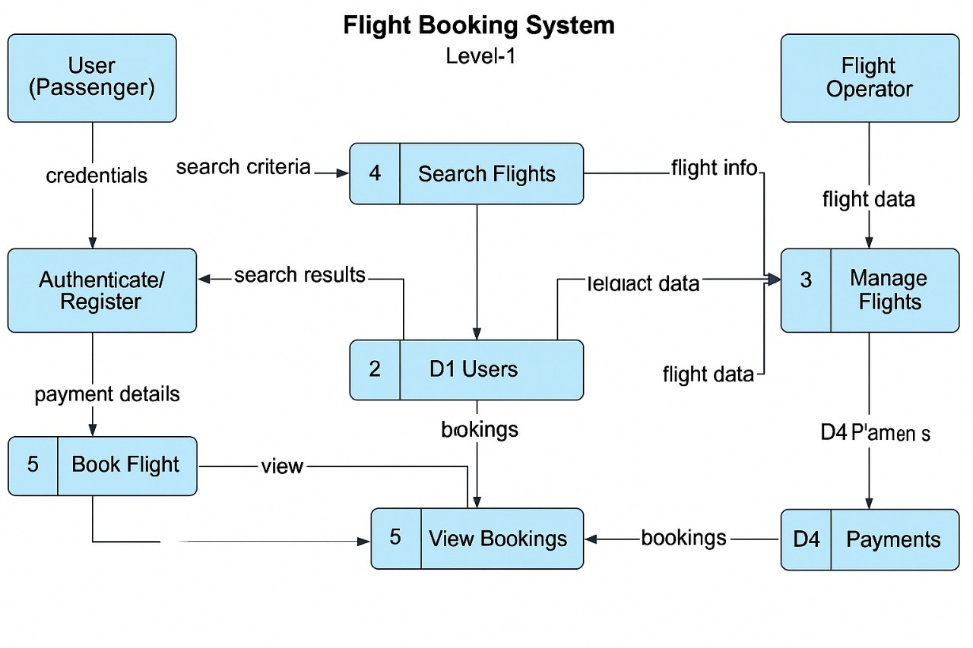

**User Stories**

Use the below template to list all the user stories for the product.

| **User Type** | **Functional Requirement (Epic)** | **User Story Number** | **User Story / Task** | **Acceptance criteria** | **Priority** | **Release** |
| --- | --- | --- | --- | --- | --- | --- |
| Customer (Mobile user) | Registration | USN-1 | As a user, I can register for the application by entering my email, password, and confirming my password. | I can access my account / dashboard | High | Sprint-1 |
|  |  | USN-2 | As a user, I will receive confirmation email once I have registered for the application | I can receive confirmation email & click confirm | High | Sprint-1 |
|  |  | USN-3 | As a user, I can register for the application through Facebook | I can register & access the dashboard with Facebook Login | Low | Sprint-2 |
|  |  | USN-4 | As a user, I can register for the application through Gmail | I can register & access dashboard via Gmail login | Medium | Sprint-1 |
|  | Login | USN-5 | As a user, I can log into the application by entering email & password | I can log in and see my dashboard | High | Sprint-1 |
|  | Dashboard | USN-6 | As a user, I can view upcoming bookings and personal details | I can view trips and profile after login | High | Sprint-2 |
| Customer (Web user) | Booking | USN-7 | As a user, I can search for flights using origin, destination, and date filters | I can see a list of available flights matching my filters | High | Sprint-1 |
| Customer Care Executive | Manage Bookings | USN-8 | As a CCE, I can view customer bookings by booking ID or user email | I can search and view booking details | High | Sprint-2 |
| Administrator | User Management | USN-9 | As an admin, I can view and deactivate any user accounts | I can enable/disable accounts from the admin panel | High | Sprint-1 |
|  | Flight Management | USN-10 | As an admin, I can add/edit/delete flight data | I can manage flights through the backend UI | High | Sprint-3 |